The Application of Copula in Credit Risk Management

JCIC Risk Research Team
Lai Bo-Chih
1. Introduction

With the final version of Basel II released at the end of June this year, the professional techniques for creating and managing credit risk models has become a vital issue for financial institutions. The approaches to risk measurement in the past focused on measuring the risk of individual obligor and then summing them up. In recent years, more attention is paid to the assessment of portfolio risk. One critical yet thorny question faced by banking supervisory authorities and risk managers in gauging portfolio risk is: how to determine and estimate the joint change of the credit rating and probability of default of counterparties to various credit assets in the portfolio (e.g. bonds, loans, credit derivatives, etc.). The credit risk models CreditManager from RiskMetrics and PortfolioManager from KMV all assume that the joint change of credit rating and probability of default observe multinormal distribution. But empirical studies show that few data in finance and insurance completely follow the rules of multinormal distribution (Embrechts et al.1999). Also given that macroeconomic cycle would bring about the time series behavior of transition matrix (Coleman 2002, Bangia et al 2000), the hypothesis of multinormal distribution tends to underestimate portfolio credit risk by underestimating the probability of a catastrophic event (e.g. financial crisis) or simultaneous decline in equity prices or simultaneous default of several counterparties during global economic slump (e.g. in the early 2000s).

In the past, it was a highly complex task in both theoretical deduction and computation to fit to a multivariate joint probability distribution. In particular when the number of assets in the portfolio is huge, it is almost unlikely to accurately estimate the joint probability distribution. The common approach to this challenge was to assume that the return on asset observes the multinormal distribution and carry on the simulation based on such assumption. The copula approach introduced in this article was first proposed by Sklar (1959) in French, which has not been applied in the finance until 1999, but studies on its application have been growing fast since. The copula approach offers a new way of thinking to simplify the problem described above, and further, measure more accurately the potential risk faced by banks. In this article, we will introduce the theoretical basis of copula in the following section. In section 3, the steps of applying copula to credit risk modeling are discussed; in section 4, empirical study is carried out using data in Taiwan; and in the final section, the potential applications of the copula approach is discussed.

2. Introduction to Copula

Definition 2.1 (Definition of copula function)
Copula, expressed as$C$ is a multi-dimensional function having uniform marginal distribution that satisfies the following three conditions:
1. $C:[0,1]^{n}→[0,1]$;
2. C is a grounded and n-increasing function;
3. C has margins$C_{i}$that satisfy$C_{i}(u)=C(1,\text{.}\text{.}\text{.},1,u,1,\text{.}\text{.}\text{.},1)=u$ $u∈[0,1]$ ■

If$F_{1},\text{.}\text{.}\text{.},F_{n}$ are univariate cumulative distribution functions (cdf), then $C[F_{1}(x_{1}),\text{.}\text{.}\text{.},F_{n}(x_{n})]$ represents a multivariate cdf with margins$F_{1},\text{.}\text{.}\text{.},F_{n}$. Based on the definition above, it is clear that copula is a function of joint probability distribution. In practical application, the Sklar’s theorem discussed below is the most important theorem for copula function.

Theorem 2.1 (Sklar’s Theorem)
If$F(⋅)$ is an n-dimensional cdf with continuous margins$F_{1},\text{.}\text{.}\text{.},F_{n}$, we can find the following unique copula representation:
$F(x_{1},\text{.}\text{.}\text{.},x_{n})=C(F_{1}(x_{1}),\text{.}\text{.}\text{.},F_{n}(x_{n}))$……………(1) ■

Based on the aforementioned theorem, we can split a multi-dimensional distribution into univariate margin and dependence structure by following the deduction below:
$\begin{aligned}f(x_{1},\text{.}\text{.}\text{.},x_{n})=\frac{∂F(x_{1},\text{.}\text{.}\text{.},x_{n})}{∂x_{1}\text{.}\text{.}\text{.}∂x_{n}}=\frac{∂C(F_{1}(x_{1}),\text{.}\text{.}\text{.},F_{n}(x_{n}))}{∂x_{1}\text{.}\text{.}\text{.}∂x_{n}}=\frac{∂C(u_{1},\text{.}\text{.}\text{.},u_{n})}{∂u_{1}\text{.}\text{.}\text{.}∂u_{n}}×\prod_{i}{\frac{∂F_{i}(x_{i})}{∂x_{i}}} \\ \begin{matrix} & & \end{matrix}=c(u_{1},\text{.}\text{.}\text{.},u_{n})×\prod_{i}{f_{i}(x_{i})}=c(\tilde{u})×\prod_{i}{f_{i}(x_{i})}\end{aligned}$..(2)
where $f(x_{1},\text{.}\text{.}\text{.}\text{.},x_{n})$ is probability density function of$F(⋅)$
$u_{i}=F_{i}(x_{i})$, $i=1,\text{.}\text{.}\text{.},n$
$\tilde{u}=(u_{1},\text{.}\text{.}\text{.},u_{2})$
$c(\tilde{u})$denotes the density function of copula

From Formula (2), we can separate a joint probability density function$f(x_{1},\text{.}\text{.}\text{.}\text{.},x_{n})$into two parts; the front part$c(\tilde{u})$is the copula density function to specify the correlation structure between variables$X_{1},X_{2},\text{.}\text{.}\text{.},X_{n}$, that is, determining the co-movement between variables may be viewed as a part of dependence structure; the latter part$\prod_{i}{f_{i}(x_{i})}$is simply the product of marginal probability density functions. That is, we can first decide the (different) marginal distribution function$F_{i}(x_{i})$, i=1,2,…,n ,of individual risk variable$X_{i}$, fit the individual marginal distribution and estimate their parameters (which can be achieved using regular statistical methods, e.g. method of movement, maximum likelihood, etc.), and then find the appropriate dependence structure (copula function) to obtain the joint probability distribution. By first separating the margins and dependence structure and then integrating them, we can explore the co-movement between variables with more flexibility and efficiency, and thereby obtain more appropriate joint probability distribution as basis for assessing portfolio risk exposure or product pricing.

Under extreme circumstances when the variable are independent of each other, $C(u_{1},\text{.}\text{.}\text{.},u_{n})=u_{1}×\text{.}\text{.}\text{.}×u_{n}$. In this article, we employ the two most commonly used copula functions - normal copula and t-copula.
Normal copula is the copula of multivariate normal distribution. It is defined as follows: Assuming$X=(X_{1},X_{2},\text{.}\text{.}\text{.},X_{n})$is multivariate normal, if and only if (a) its margins$F_{1},\text{.}\text{.}\text{.},F_{n}$ are normally distribution, and (b) a unique copula function (i.e. the normal copula) exists, such that
$C_{R}^{N}(u_{1},\text{.}\text{.}\text{.},u_{n})=Φ_{R}(φ^{−1}(u_{1}),\text{.}\text{.}\text{.},φ^{−1}(u_{n}))$ …………………………………(3)
where$Φ_{R}$ denotes the standard multivariate normal distribution with correlation matrix$R$and$φ^{−1}$ is the inverse function of standard univariate normal distribution.

When n=2, we can obtain the copula function as follows:
$$C_{R}^{N}(u,v)=\int_{−∞}^{φ^{−1}(u)}{\int_{−∞}^{φ^{−1}(v)}{\frac{1}{2π(1−R_{\text{12}}^{2})^{1/2}}\text{exp}\left\{−\frac{s^{2}−2R_{\text{12}}\text{st}+t^{2}}{2(1−R_{\text{12}}^{2})}\right\}\text{dsdt}}}$$
By the same concept, t-copula is the copula function of multivariate Student’s t distribution. Assuming$X=(X_{1},X_{2},\text{.}\text{.}\text{.},X_{n})$observes standard multivariate normal distribution with correlation matrix$R$, $Y$is the random variable of$χ^{2}$distribution with$v$degree of freedom, then t-copula function is:
$C_{v,R}^{t}(u_{1},\text{.}\text{.}\text{.},u_{n})=t_{v,R}(t_{v}^{−1}(u_{1}),\text{.}\text{.}\text{.},t_{v}^{−1}(u_{n}))$ ………………………………….(4)
where $u_{i}=\frac{\sqrt{v}}{\sqrt{Y}}X_{i},$ $i=1,\text{.}\text{.}\text{.},n$
When n=2, we can obtain the t-copula as follows:
$$C_{v,R}^{t}(u,v)=\int_{−∞}^{t_{v}^{−1}(u)}{\int_{−∞}^{t_{v}^{−1}(v)}{\frac{1}{2π(1−R_{\text{12}}^{2})^{1/2}}{\left\{1+\frac{s^{2}−2R_{\text{12}}\text{st}+t^{2}}{v(1−R_{\text{12}}^{2})}\right\}}^{−(v+2)/2}\text{dsdt}}}$$
The difference between normal-copula and t-copula can be illustrated with two-dimensional random variable scatter plot using simulation method. Fig. 2-1 depicts the scatter plot of two random variables with the same correlation coefficient (assuming 0.3) under different marginal distribution and different dependence structure. When marginal distribution is normal and dependence structure is normal-copula (i.e. multivariate normal distribution), the variable distribution is most concentrated; when the marginal distribution is t distribution and the dependence structure is t-copula (i.e. multivariate t-distribution), the variable distribution is most scattered. We can also simulate the situation where the marginal distribution is normal but the dependence structure is driven by t-copula as shown in the lower left graph in Fig. 2-1, or the situation where marginal distribution is t-distribution but dependence structure is driven by normal-copula as shown in the upper right graph in Fig. 2-1. The random variables produced by such approach are different from conventional distribution, allowing random combination of margin and dependence structure, hence offering greater flexibility in the fit of joint distribution. As shown in Fig. 2-1, the effect of different marginal distributions is striking. Relatively, the effect of dependence structure (t-copula or normal-copula) on data distribution is less pronounced.
Fig. 2-1 5000 Monte Carlo Simulations of random variable with normal-copula or t-copula 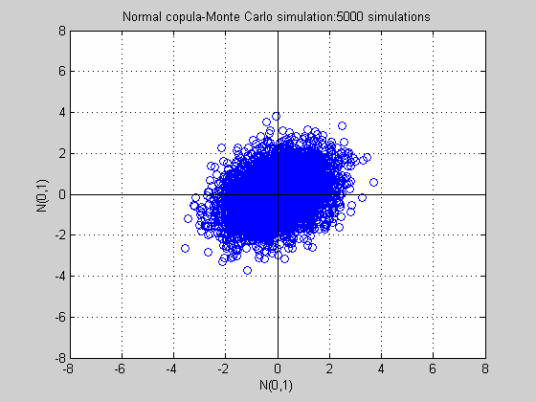 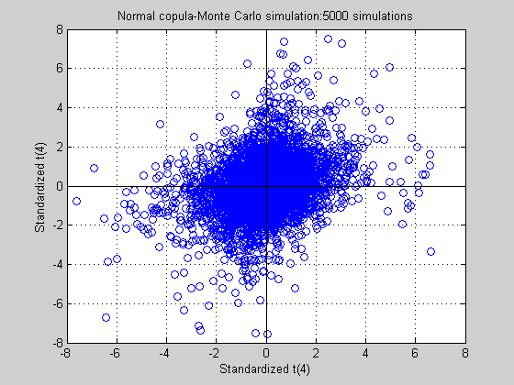
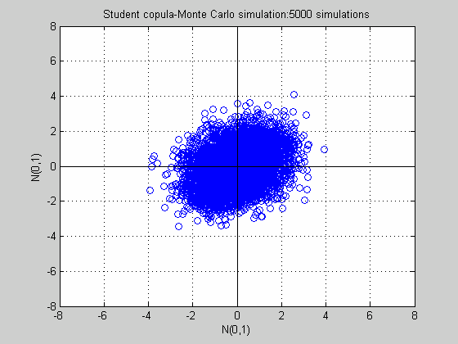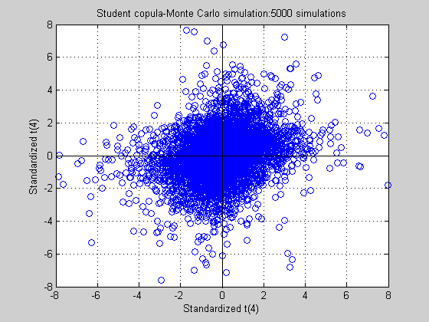
Note: Assuming the correlation coefficient between two variables is 0.3, and degree of freedom in Student’s t distribution is 4.

3. Application of copula approach to credit risk management

As pointed out earlier, the greatest advantage of copula function is to allow the separation of margin and dependence structure. We can view$X_{i}$ as the return of each risk factor (e.g. stock price index, interest rate or exchange rate). As such, the fit of each risk factor is not constrained by the assumptions under normal distribution, but could be based on actual market data to obtain more accurate distribution, and the risk factors can have different margins, for examples, some are normal distribution, some are t distribution and others have fat tail or skewness as in normal-inverse Gaussian distribution. Next the most suitable copula function is selected based on the relevant properties of risk factors to obtain the joint changes of portfolio. This article aims to introduce the application of copula to credit exposure. For detailed descriptions of market risk, readers can refer to relevant literature, such as Romano (2002) and Dowd (2002).

The computation of credit risk in this study is based on structural model where the credit loss distribution is estimated by Monte Carlo simulation. Here we assume indicator variable$y_{i}$represents the default state of obligor i during a time interval [0,T], that is:
$y_{i}=\left\{\begin{matrix}1 & \text{default} \\ 0 & \text{otherwise}\end{matrix}\right.$ (i=1,…,N)
We determine the default of each obligor by two variables. The first variable $X_{i}$represents the asset value of obligor i, and the relationship between asset value$X_{i}$and default incidence$y_{i}$is linked up using another variable$D_{i}$, which is the threshold value. Default occurs when the asset value of an obligor$X_{i}$ becomes less than the threshold value$D_{i}$as expressed below:

$X_{i}≤D_{i}⇔y_{i}=1$ (i=1,…,N)
All conventional portfolio risk models assume$X=(X_{1},\text{.}\text{.}\text{.},X_{N})$obeys multinormal distribution. But empirical studies have shown that such assumption fails to fit the actual market conditions. Using the methodology discussed in the previous section, we can estimate risk exposure more accurately using different margins and dependence structures given from the copula function.

4. Empirical Study

From the JCIC database, we obtained the data on 150,000 obligors of banks across the country. For the purpose of empirical study, we sampled enterprises with paid-in capital of at least NT$300 million in December 2000, and 3,030 samples were selected. To facilitate computer operation, we defined the date of default as the (1) the first month any bank reported overdue loan, loan on demand or bad debt on the obligor or (2) the date the obligator was denied service by the check clearing house, whichever happened first.

First we used convention simulation methodology, assuming the asset change of each obligator observes multinormal distribution with correlation coefficient between obligors at 0.15, and using the average rate of 2.5% in the previous year as default for probability of default (PD), and performed 1000 Monte Carlo simulations to obtain the portfolio loss distribution shown in Fig. 4-1. Based on this model, we carried out scenario analysis over various factors affecting the credit portfolio. The effect of change of PD on loss distribution can be surmised, as shown in Table 4-1, that when PD rises, all credit risks increase, a phenomenon that fits the general expectation.

Table 4-2 depicts the change of loss distribution when the correlation coefficient of the obligors changes. It is found that no matter how correlation coefficient changes, it does not produce much effect on expected loss (EL). But as the level of confidence increases, the magnitude of change in credit exposure increases as correlation coefficient increases.

Fig. 4-1 Simulated Portfolio Loss Distribution
Loss Distribution
Note: 1000 Monte Carlo simulations with normal-copula was used.

Table 4-1 Effect of different probability of default on loss distribution
Probability of default (PD) | Default -1% | Default | Default +1% | Default +2% | Default +3%
Expected loss (EL) | 0.78% | 1.16% | 1.70% | 2.15% | 2.56%
Credit risk (95%) | 2.67% | 3.72% | 5.02% | 6.19% | 7.07%
Credit risk (99%) | 4.49% | 5.78% | 8.75% | 9.49% | 10.48%
Credit risk (99.9%) | 6.76% | 8.93% | 13.20% | 14.15% | 16.08%
Note: The default PD 2.5%, correlation coefficient 0.15, normal-copula model used.

Table 4-2 Effect of correlation between obligators on loss distribution
Correlation coefficient | 5.00% | 10.00% | 15.00% | 20.00% | 25.00%
Expected loss (EL) | 1.14% | 1.16% | 1.16% | 1.17% | 1.16%
Credit risk (95%) | 2.61% | 3.09% | 3.72% | 4.08% | 4.47%
Credit risk (99%) | 3.41% | 5.27% | 5.78% | 7.02% | 7.86%
Credit risk (99.9%) | 5.22% | 7.27% | 8.93% | 12.62% | 12.33%
Note: Default PD 2.5%, normal-copula model used.

Table 4-3 Effect of different copula functions on loss distribution
Copula function | Normal | t(20) | t(10) | t(4) | t(2)
Expected loss (EL) | 1.16% | 1.18% | 1.17% | 1.19% | 1.16%
Credit exposure (95%) | 3.69% | 4.48% | 5.00% | 7.26% | 7.59%
Credit exposure (99%) | 5.78% | 7.17% | 9.78% | 16.53% | 19.22%
Credit exposure (99.9%) | 8.93% | 10.88% | 14.37% | 24.43% | 26.28%
Note: Default PD 2.5%, correlation coefficient 0.15.

In Table 4-3 which shows the effect of different dependence structures on loss distribution, it is found that the variation of correlation coefficient did not produce effect on the size of expected loss. But when credit exposure with higher level of confidence had bigger changes, meaning the primary effect of dependence structure is at tail, the estimation of credit loss for the portfolio with dependence structure deviating more from the norm will be bigger when a crisis event occurs.

After the simulations as described above, “which dependence structure fits Taiwan’s data better” is a next question to be tackled. Given that time interval in the credit risk model is typically one year and there is no bank on the market having more than one hundred years of credit data available, the model verification, unlike that for market risk model, cannot employ retrospective testing. Under the circumstances of inadequate samples, we made reference to the articles of Lopez and Marc (1999) and Ching (2002) and made use the characteristics of the JCIC data to classify the 2000 and 2001 data by bank, set the default loss rate at 45%, and computed the loss distribution using normal-copula and t(10)-copula respectively. We also compared the transfinite over real loss distribution at 95% and 99% confidence level. The results are presented in Table 4-4, Fig. 4-2 and Fig. 4-3. We chose 45 banks for the study. That means there were 90 sets of data over the two-year period. At 95% confidence level, 4.5 banks showed transfinite number. But as many as 15 banks had transfinite number under normal-copula simulation as shown in Table 4-4. Similarly at 99% confidence level, 3 banks had transfinite number under normal-copula simulation, which was also far higher than being reasonable. Thus we find that using conventional multinormal distribution alone to assess the credit risk in Taiwan’s market would result in significant underestimation of credit exposure. In t(10)-copula simulation, the number of banks with transfinite number was 2 and 1 at 95% and 99% confidence level respectively. Such figures approximate the theoretical values, meaning this approach could help preclude the overestimation or underestimation of credit exposure.

5. Conclusion
This article finds that copula function provides a valuable instrument in risk management. It gives the risk prediction models great flexibility. Given that copula function is applicable to the part of dependence structure, it can be used in any fields associated with correlation.

Table 4-4 The number of banks showing transfinite number over real loss in each year using different copula functions
 | 2000 (N-copula) | 2001 (t10-copula) | 2000 (N-copula) | 2001 (t10-copula)
Credit exposure (99%) | 2 | 0 | 1 | 1
Credit exposure (95%) | 7 | 0 | 8 | 2

Fig. 4-2 The number of banks showing transfinite number over real loss in 2000
Note: The 2000 data (12 months) used 3000 Monte Carlo simulations with normal-copula function and normal marginal distribution.

Fig. 4-2 The number of banks showing transfinite number over real loss in 2000
Note: The 2000 data (12 months) used 3000 Monte Carlo simulations with t(10)-copula function and t(10) marginal distribution.

The discussion of this article is limited to the application of copula function to credit risk management. There have been copula researches in recent years on market risk, operation risk, asset pricing and the pricing of credit derivatives, and some securities firms abroad are resorting to copula approach in pricing their products. As securitized products become more prevalent in the domestic market, we believe the copula approach will play an increasingly important role in the foreseeable future in both the industry and the academic community.

References:
1. Bangia, A., Diebold, F. X., and T. Schuermann (2000), “Ratings migration and the business cycle, with applications to credit portfolio stress testings”, Available at http://www.stern.nyu.edu/~fdiebold/.
2. Bouye, E., V. Durrleman, A. Nikeghbali, G. Riboulet and T. Roncalli (2000), “Copulas for finance—a reading guide and some application”, Groupe de Recherche
3. Coleman, M. S. (2002), “Simulating historical ratings transition matrices for credit risk analysis in Mathematica”, SCI 2002 Credit Risk Paper
4. Dowd, K. (2002), “Measuring market risk”, Wiley.
5. Embrechts, P., A. McNeil and D. Straumann (1999), “Correlation and dependence in risk management: Properties and pitfalls”, Mimeo. ETHZ Zentrum, Zurich.
6. Frey, R., McNeil, A. J., Nyfeler, M. A. (2001), “Copulas and credit models”, Working paper.
7. Jackel, P. (2002), “Monte Carlo methods in finance”, Wiley.
8. Li, D. (2000), “On default correlation: a copula approach”, Journal of Fixed Income, 9(3), 43-54.
9. Lopez, and Marc(1999), “Evaluating Credit Risk Models”, Journal of Banking and Finance 24, 151-165.
10. Merton, R. (1999), “On the Pricing of Corporate Debt: The Risk Structure of Interest Rates”, Journal of Finance, 29, 449-470.
11. Nelsen, R. (1999), “An Introduction to Copulas”, Springer, New York.
12. Sklar, A. (1959), “Fonctions de reparition a n dimensions et leurs marges”, Publications de 1’Institut de Statistique de 1’Universite de Paris, 8, 229-231.
13. Romano, C. (2002), “Applying copula function to risk management”, Available at http:// www.gloriamundi.org/picsresources/cr04.pdf
14. Ching, Y. C. (2002), “Examination of Credit Risk Model - In the Case of Taiwan’s Finance Industry”, Currency Watch and Credit Rating, Vol. 35, 120-126.

